How to compile and run a .java program

Felipe .M Iglesias

February 2025



CONTENT

1. Download JDK 2

2. Set the environment PATH variable in PowerShell: 2

3. Check that the environment PATH was set: 3

4. Check Javac and Java are properly installed: 3

5. Write your Java program 4

6. Compile the .java file using Javac 4

7. Check that the new file was created 5

8. Run the program 5



# **1. Download JDK**

<https://www.oracle.com/java/technologies/downloads/>

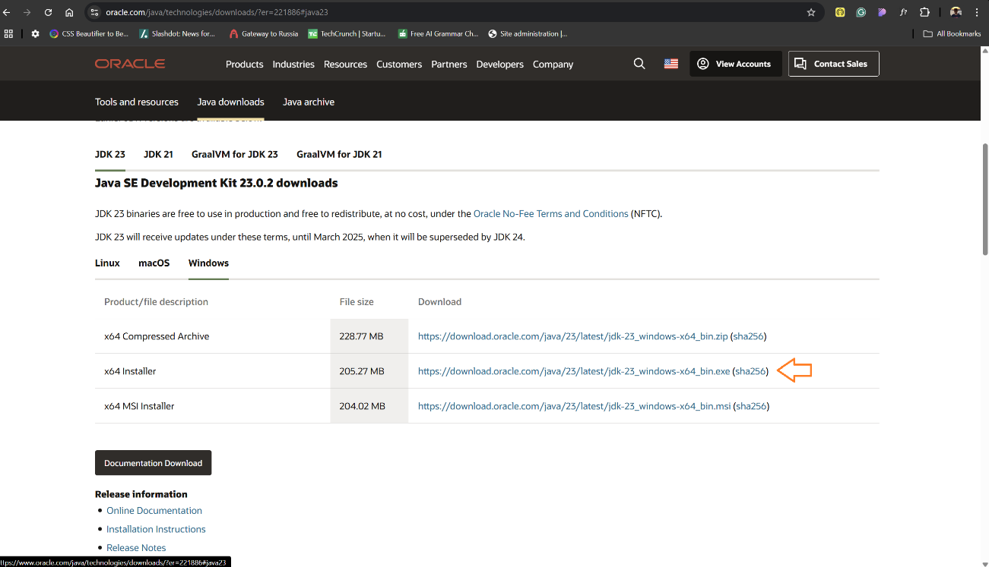

# **2. Set the environment PATH variable in PowerShell:**

[System.Environment]::SetEnvironmentVariable("Path", $env:Path + ";<path to the JDK bin>", "User")

# **3. Check that the environment PATH was set:**

$env:Path -split ";"

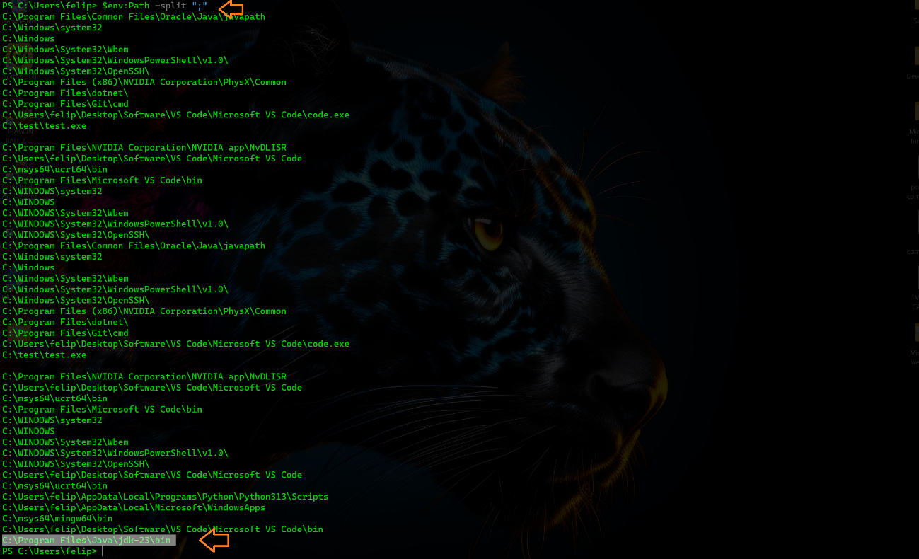

# **4. Check Javac and Java are properly installed:**

javac -version

java -version

# **5. Write your Java program**

# **6. Compile the .java file using Javac**

javac <file name>.java

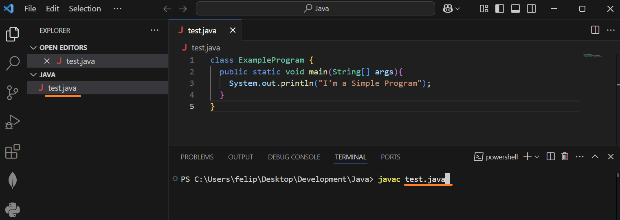

# **7. Check that the new file was created**

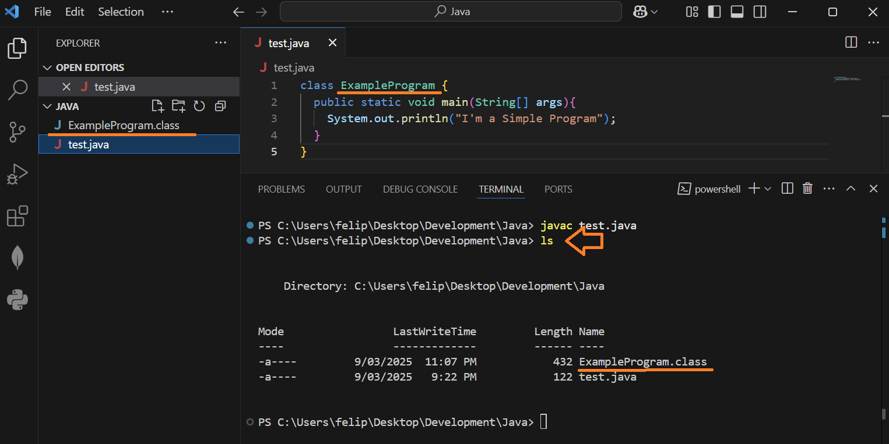

# **8. Run the program**

java <file name>

(don’t include the extension in the file name)

